Home exercises
When completing your home exercises, ensure you stand near a stable surface so that you can hold on if required (chair, wall or kitchen bench).
Warm up
Ensure you raise the heart rate, move your joints and muscles ready for the below exercises. Warm up exercises should take around 5-7 minutes. Cycle through the following exercises:
- On the spot marching: 1 minute
- Circle the shoulders and wrists whilst still marching: 1 minute
- Add in 10 knee bends (mini squat): 30 seconds
- Back to marching, this time pick your knees up higher: 1 minute
- Add in 10 heel digs on each side, followed by 10 toe taps on each side: 1-2 minutes
- Back to marching, this time increase your pace and time. Keep your knees high: 2 minutes
Exercises
- Squats
Using a hand support as required, stand with feet
shoulder width apart. Keep your heels on the ground
knees apart and behind your toes. Now sink down
into a squat.
Repeat 5-10 repetitions, 3 times over

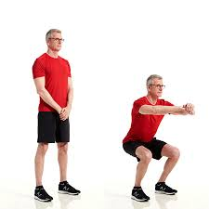

- Walking the tight rope
Begin standing with your arms raised at your sides to shoulder height. Choose a spot in front of you to focus on and remain focused on it as you move. Now place the heel of one foot just in front of the toes on your other foot. If feeling confident, repeat the same but move backwards.
Repeat for 20 steps, alternating legs

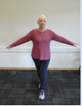
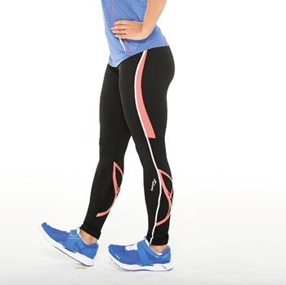
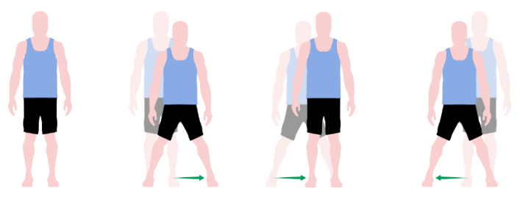
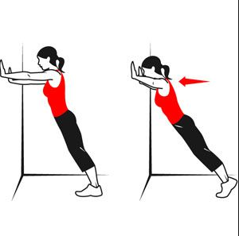
5. Heel walking
Lift both your feet so you are on your heels as you walk. Keep toes pointed forward but off the ground.
Take 20 small steps as you walk forward, then turn around and walk back. Repeat this 3 times.
- Side stepping
Stand with your feet together, knees slightly bent. Step sideways in a slow and controlled manner, moving one foot to the side first. Move the other to join it.
Repeat 10 times on each side, 3 times over
- Wall push ups
Stand facing the wall about arm’s length away. Place your hands on the wall with fingers pointing up. Your hands should be a little wider that shoulder width apart and slightly below shoulder level. Now bend your elbows and bring your chest towards the wall, between your hands. Your whole body should move forward hinging at the ankles. Then push your body away from the wall back to where you started.
Repeat 5-10 repetitions, 3 times over
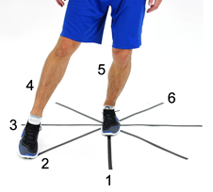
7. Torso twist
Sit towards the edge of your chair. Slowly rotate the torso to the left as far as comfortable as if turning to look over your shoulder, keeping the rest of the body still. Rotate back to the middle and rotate to the right.
Repeat for 10 on each side
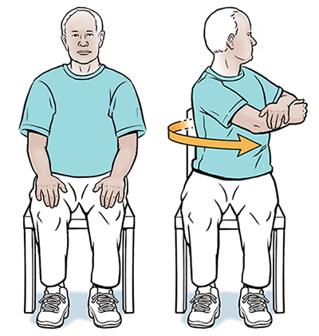
- Sit to stand
Start sitting down on a chair. Cross your arms over your chest and without using your hands to push you up, stand up. Slowly lower yourself back down to a seated position.
Repeat 10 repetitions, 3 times over
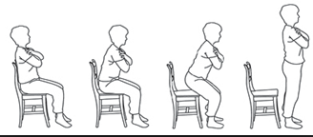
6. Around the clock balance
Stand in the middle of the “clock face”. Move your right leg out to tap 12 o’clock and work your way around the clock face. When you reach 6 o’clock you must tap your foot behind you. After 6 o’clock, change legs and finish the clock with your left leg.
Repeat 3 times each side

Cool down and Stretches
Seated hamstring stretch
Move forwards in your chair and lift one leg out resting your heel on the floor, keeping your knee straight. With your chest up, hands resting on your thighs. Breath out and bend forwards keeping your spine straight. Hold to the count of 20 and repeat on both sides.
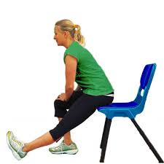

Neck stretch

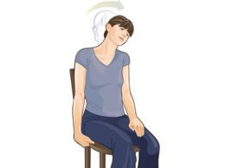
Sitting in a chair with hands down by your sides. Gently bring your ear towards your shoulder feeling the stretch on the side of the neck. Hold to the count of 20 and repeat on both sides.

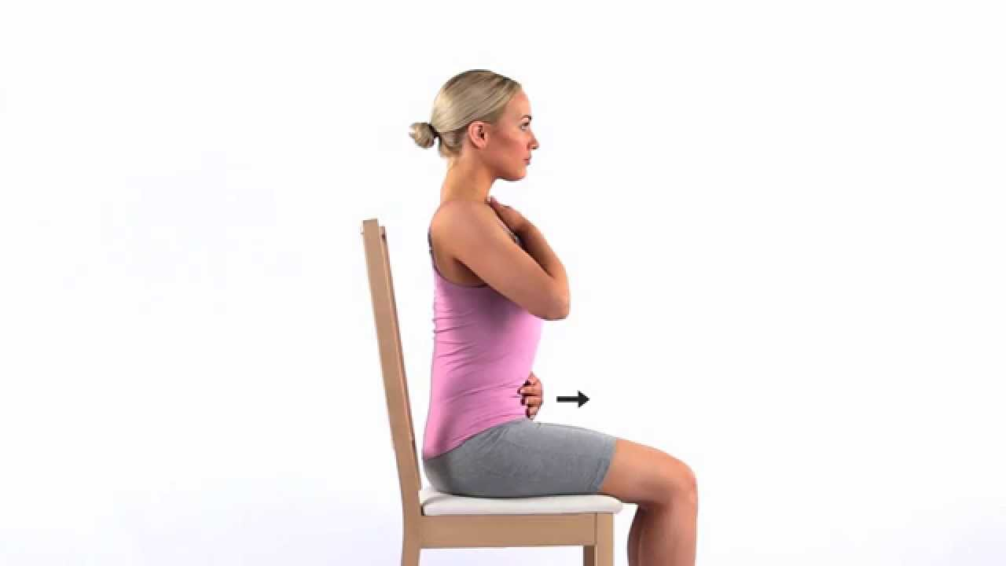
Deep breathing
Sitting in a chair, relax, take a deep breath in to the count of 5, breath out to the count of 5. Repeat 5-10 times, close your eyes if you wish.

